Obama State of the Union Text Analysis

Throughout the eight State of the Union Addresses throughout Obama’s presidency, there are some clear issues that highlight his time as president. These include the economy, healthcare, jobs, environment, and taxes. As a Democrat, Obama’s concern for the middle class is definitely apparent with this text analysis. His foreign policy is not so much of a priority for his overview either. Obama’s presidency definitely had the people’s quality of life in mind more than relations with other countries. His tactics seem similar to those of FDR’s, especially his New Deal that looked to increase the amount of jobs in order to come back from the stock market crash of 1929, just like the economic depression in 2009.

2009 (55 words)

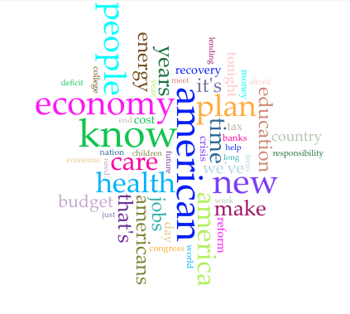

2010



2011

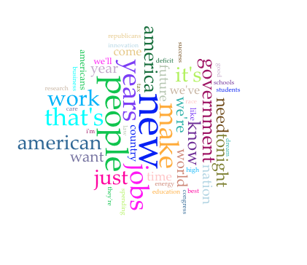

2012

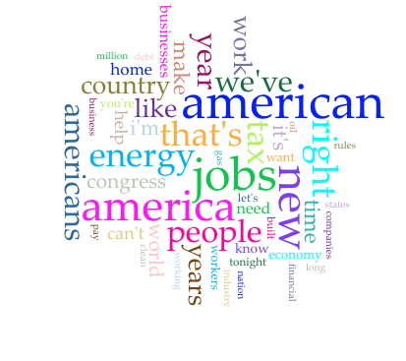

2013

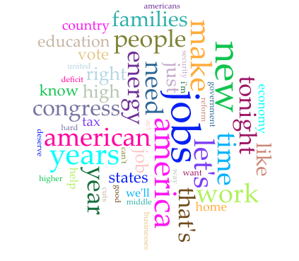

2014

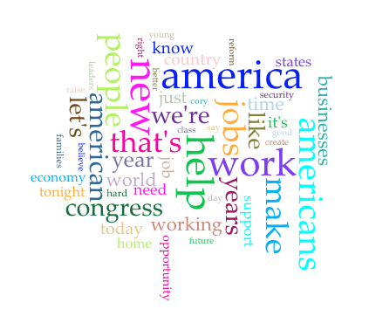

2015

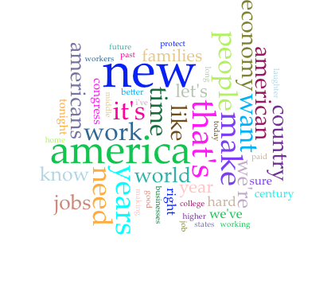

2016

